Jarron Bailey

Homework 8

Date: April 1st, 2019

**Test 1: Start program with no data file:**

Console log:

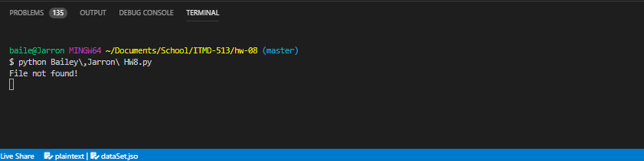

GUI: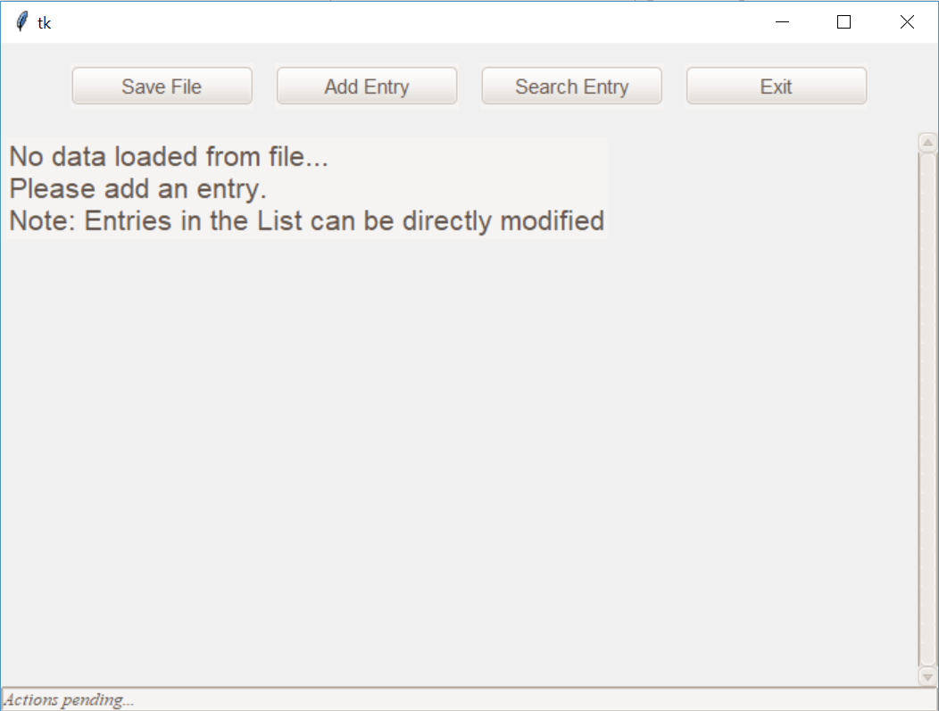

**Test 2: Start program with Sample data file:**

Console log:

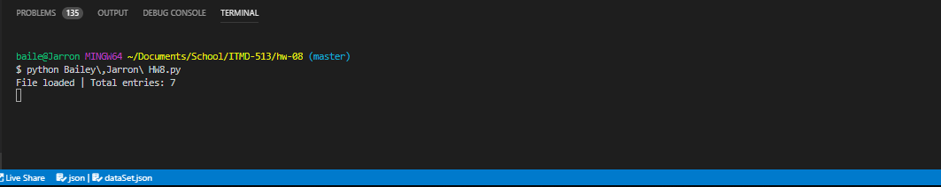

GUI:

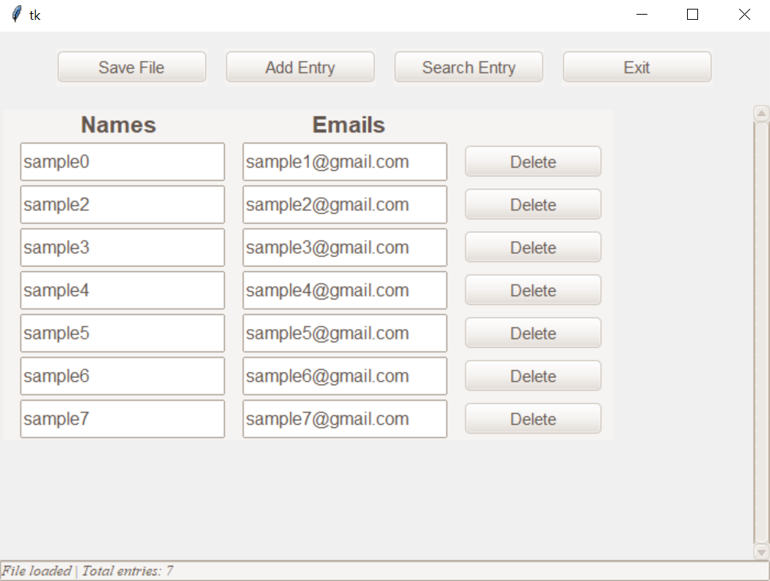

**Test 3: Add entry > Invalid email:**

Console log:

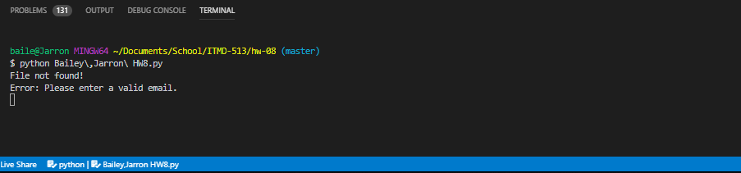

GUI:

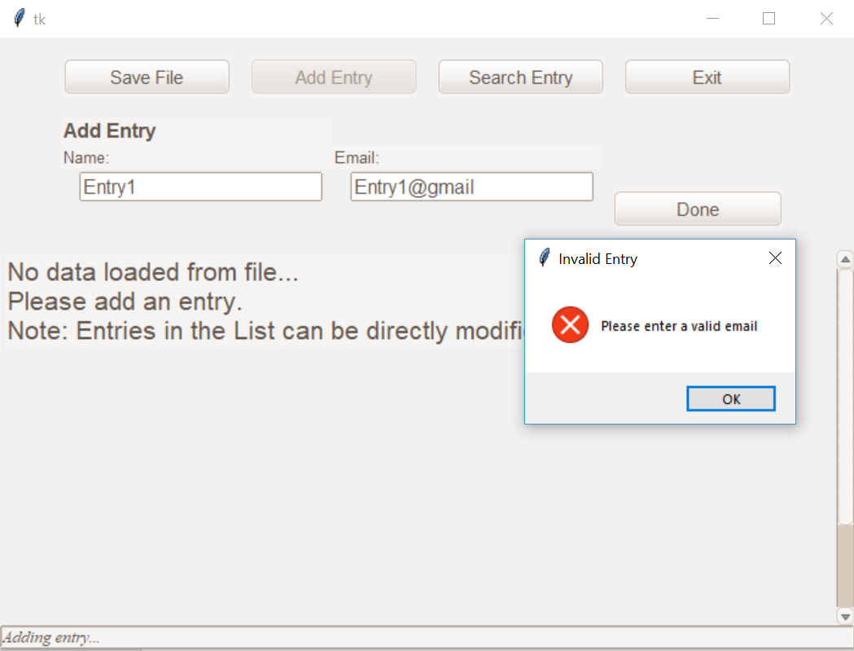

**Test 4: Add entry > valid email:**

Console log:

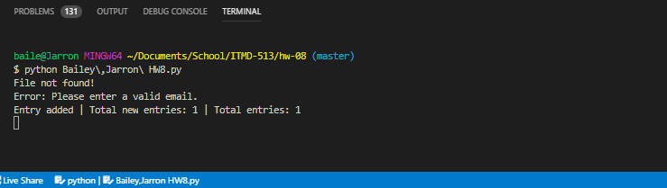

GUI:

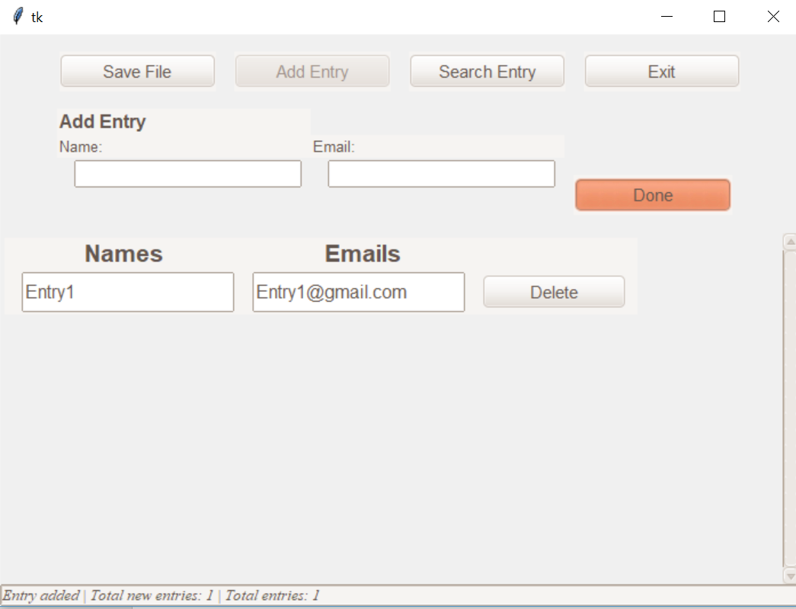

**Test 5.1: Modify name in entry list:**

Console log:

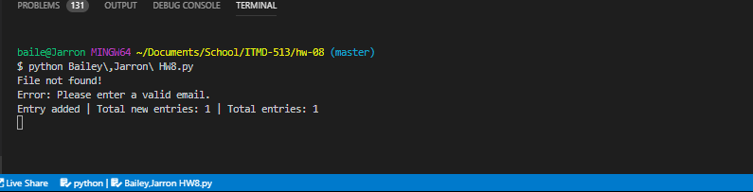

GUI:

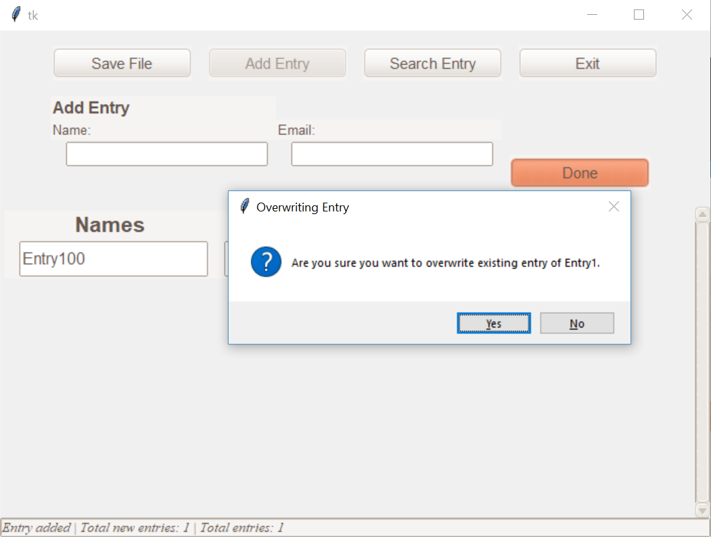

**Test 5.1: Modify name in entry list:**

GUI:



**Test 5.1: If Overwrite = Yes**

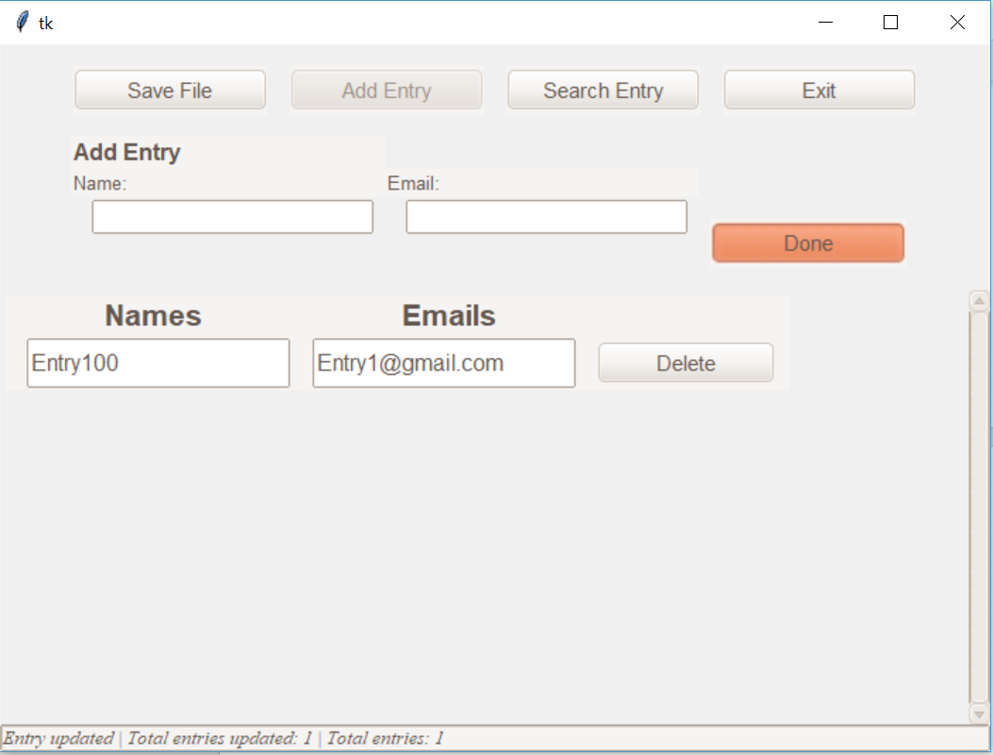

Console:

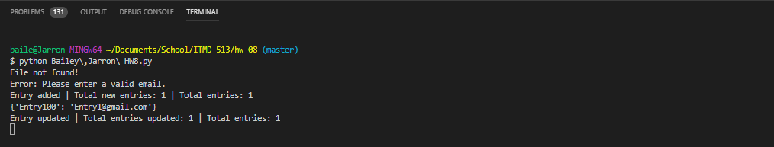

Dataset is shown here for verification of update during each modification

**Test 5.2: If Overwrite = No**

GUI: Values stay the same

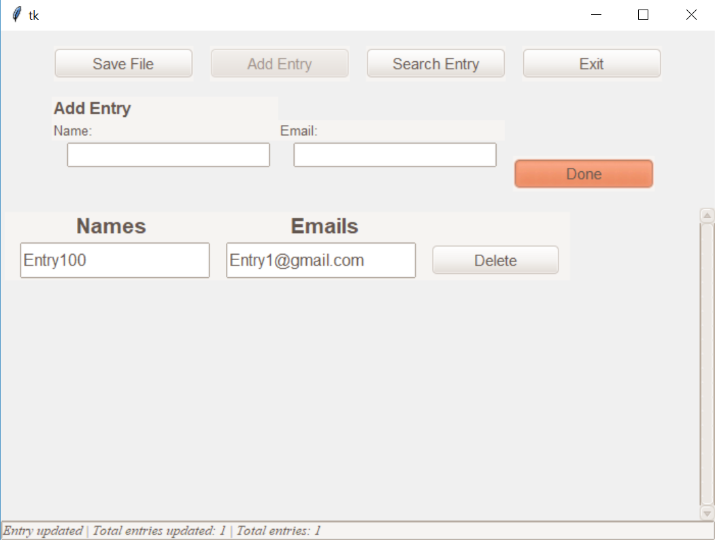

**Test 6.1: Modify email in entry list:**

GUI:

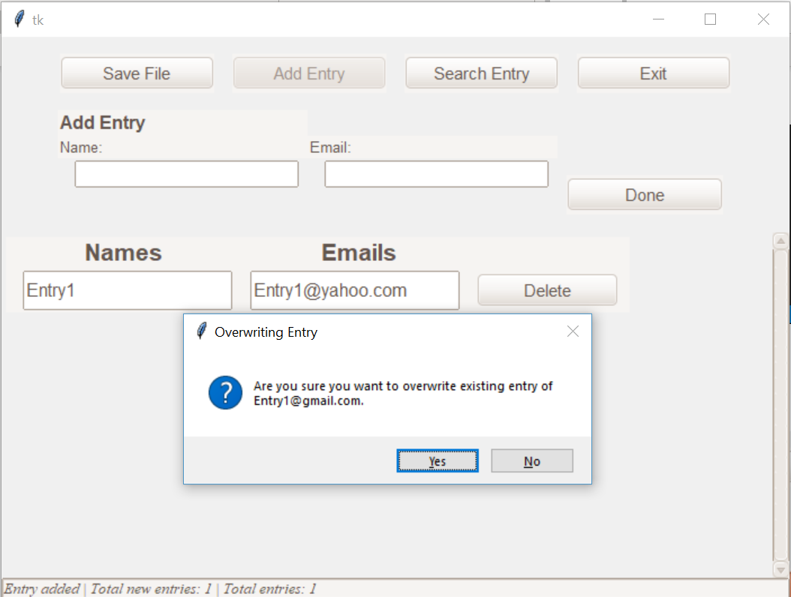

**Test 6.1 If Overwrite = Yes**

GUI: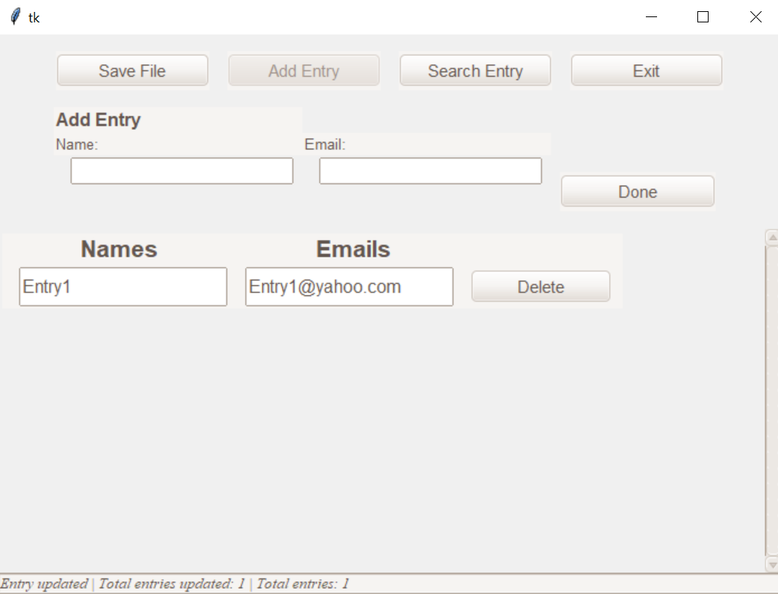

Console log:

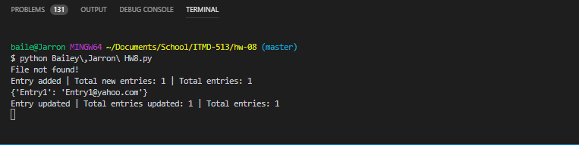

**Test 6.2 If Overwrite = No**

GUI: Values stays the same



**Test 7: Search for existing name:**

GUI:

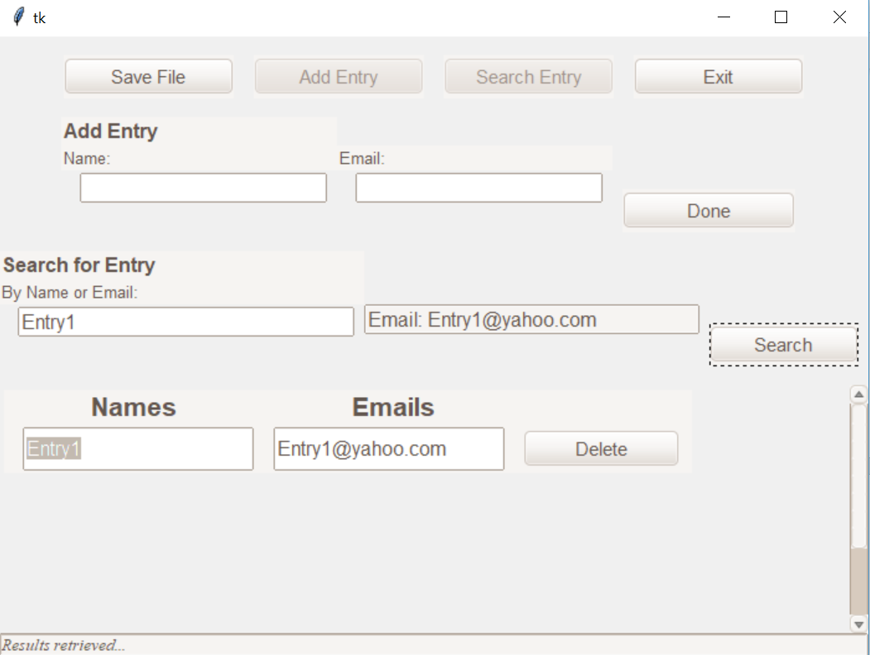

Console:

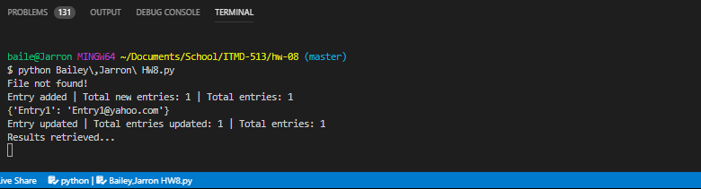

**Test 7: Search for existing email:**

GUI:

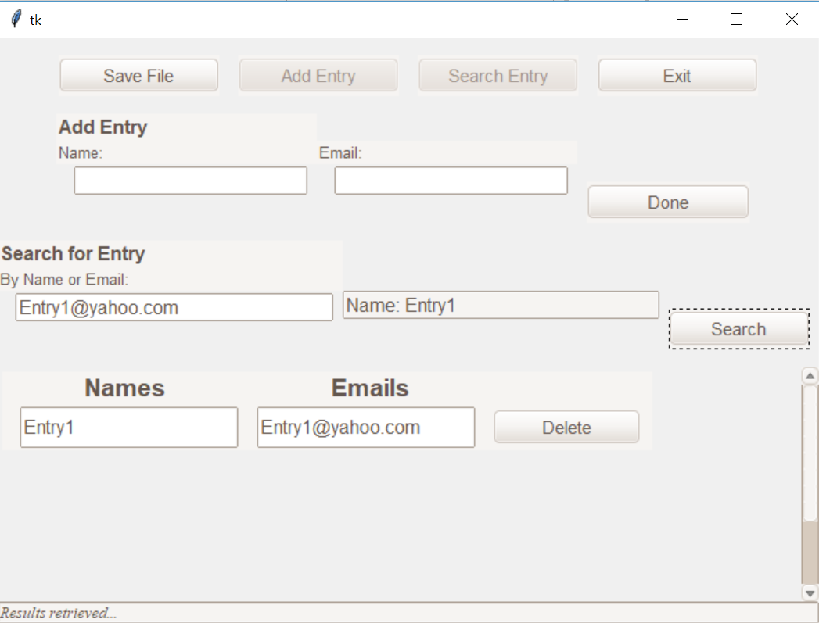

Console:

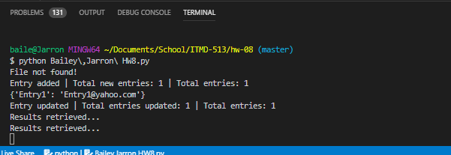

**Test 7: Search for nonexistent entry:**

GUI:

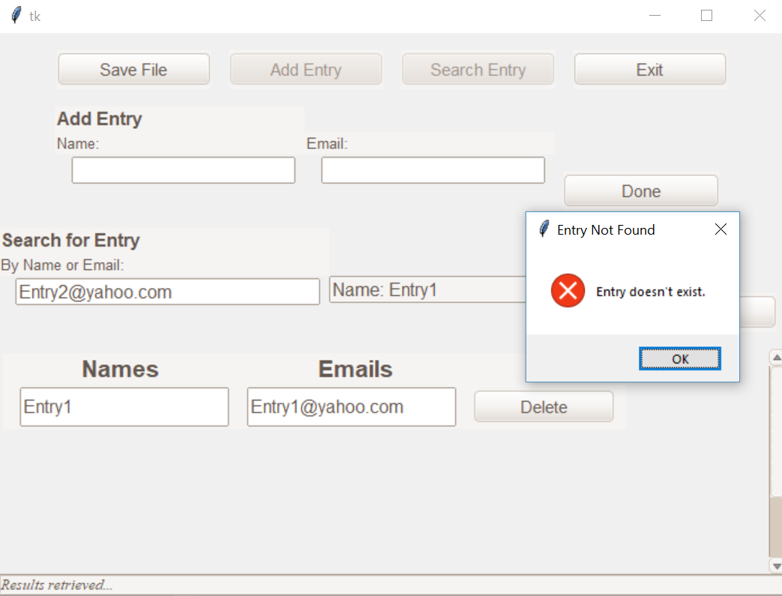

Console:

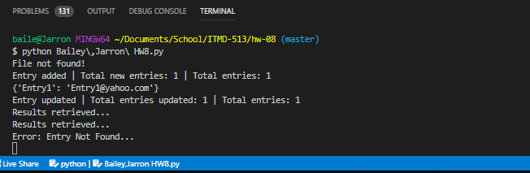

**Test 8: Add entry while name already exist:**

GUI:

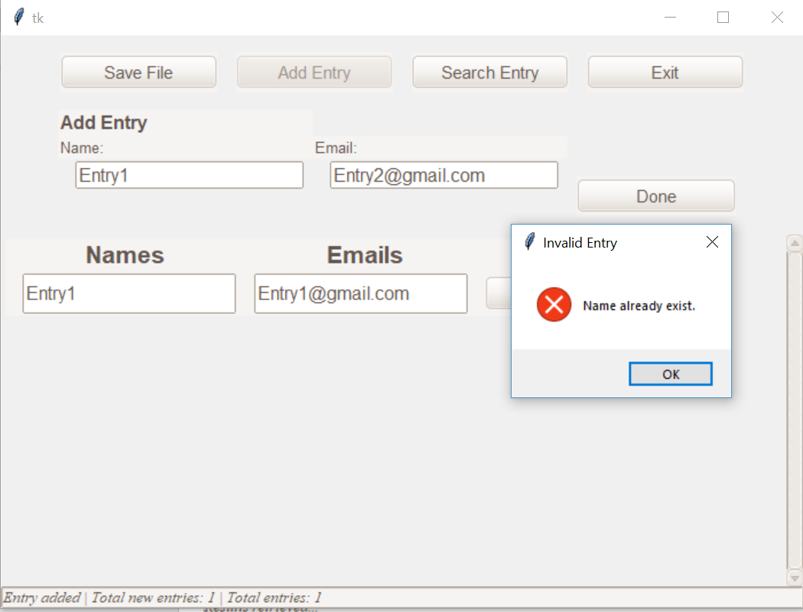

Console:

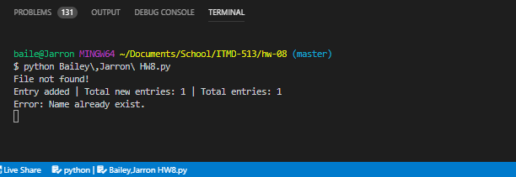

**Test 9: Add entry while email already exist:**

GUI:

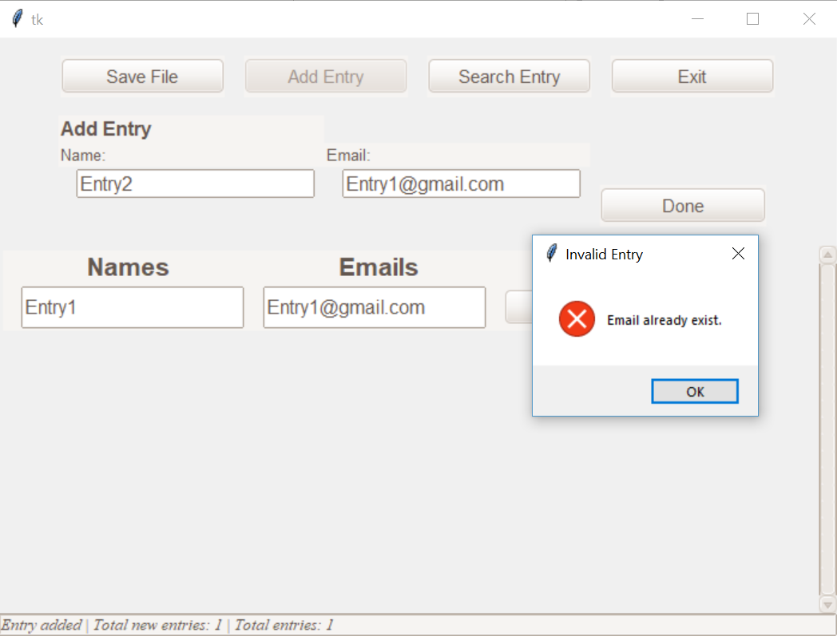

Console:

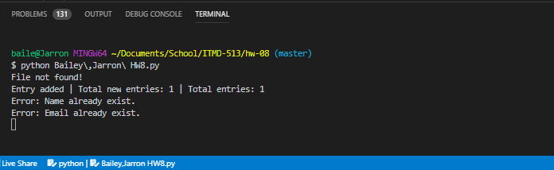

**Test 10: Save file**

* Created 5 entries
* Clicked save to file

GUI:

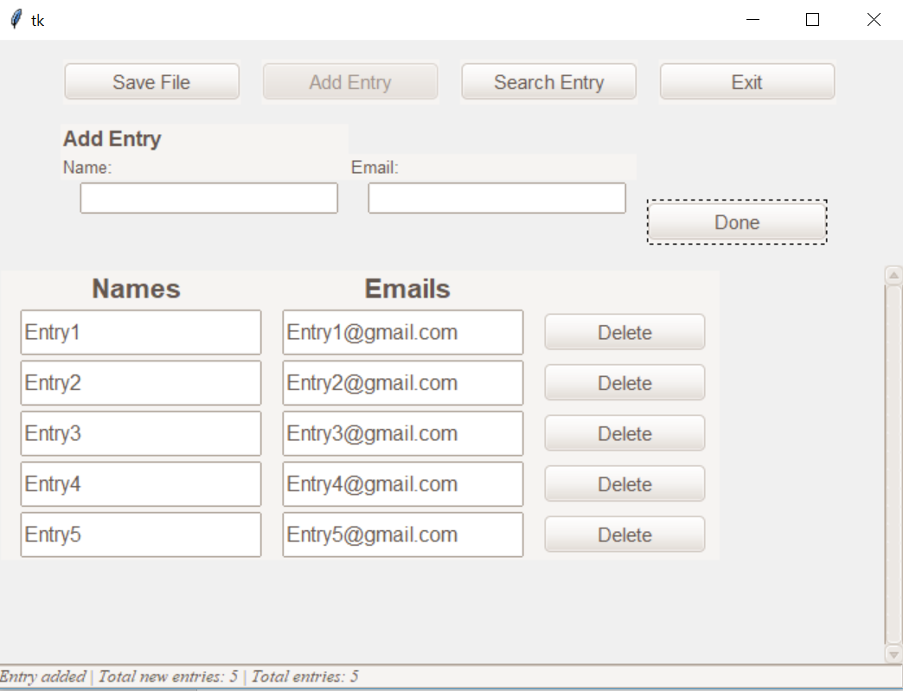

Console:

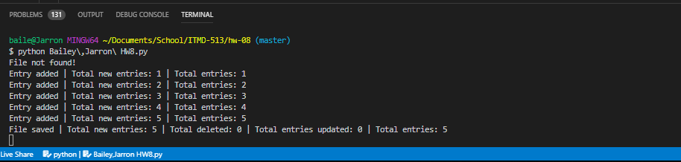

GUI: Loaded file

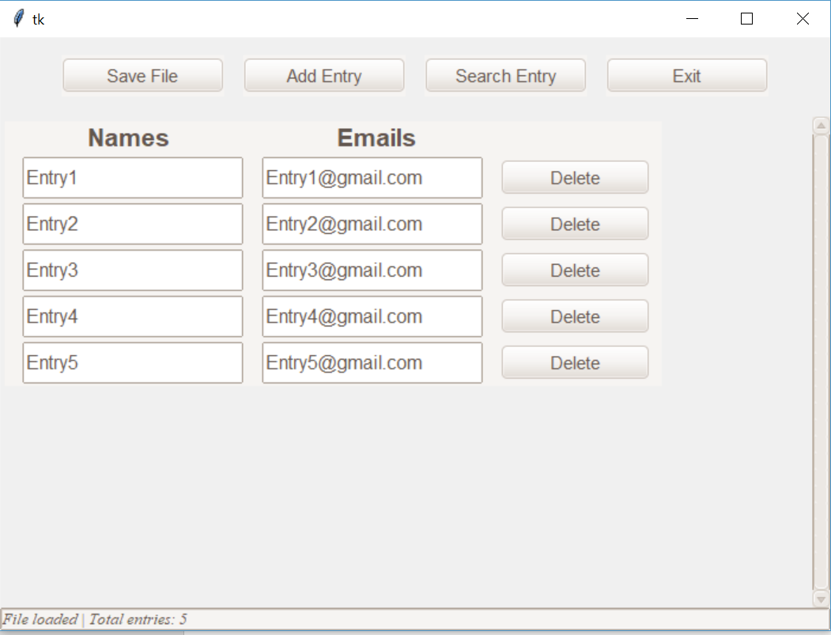

Console:

